Problem 2:

*Each salad must contain:*

* *At least 15 grams of protein*
* *At least 2 and at most 8 grams of fat*
* *At least 4 grams of carbohydrates*
* *At most 200 milligrams of sodium*
* *At least 40% leafy greens by mass*

*The nutritional contents of these ingredients (per 100 grams) and cost are:*

|  |  |  |  |  |  |  |  |
| --- | --- | --- | --- | --- | --- | --- | --- |
| Ingredient Label | Ingredient | Energy | Protein | Fat | Carbs | Sodium | Cost |
| I1 | Tomato | 21.00 | 0.85 | 0.33 | 4.64 | 9.00 | $1.00 |
| I2 | Lettuce | 16.00 | 1.62 | 0.20 | 2.37 | 28.00 | $0.75 |
| I3 | Spinach | 40.00 | 2.86 | 0.39 | 3.63 | 65.00 | $0.50 |
| I4 | Carrot | 41.00 | 0.93 | 0.24 | 9.58 | 69.00 | $0.50 |
| I5 | Sunflower Seeds | 585.00 | 23.40 | 48.70 | 15.00 | 3.80 | $0.45 |
| I6 | Smoked Tofu | 120.00 | 16.00 | 5.00 | 3.00 | 120.00 | $2.15 |
| I7 | Chickpeas | 164.00 | 9.00 | 2.60 | 27.00 | 78.00 | $0.95 |
| I8 | Oil | 884.00 | 0.00 | 100.00 | 0.00 | 0.00 | $2.00 |

*Part A: Determine the combination of ingredients that minimizes calories but meets all nutritional requirements:*

*i) Formulate the problem as a linear program with an objective function and all constraints.*

**Decision Variables**: Iy = 100 grams of each ingredient “y” to include in the salad. Each ingredient is labeled in order with the letter I and an incrementing number.

**Objective Function:** Min K = I1*21 + I2*16 + I3*40 + I4*41 + I5*585 + I6*120 + I7*164 + I8*884

Where K = kcal

**Resource Constraints:**

**Protein:** I1*.85 + I2*1.62 + I3*2.86 + I4*.93 + I5*23.40 + I6*16 + I7*9 + I8*0 ≥ 15 g of protein

**Fat Min:** I1*.33 + I2*.20 + I3*.39 + I4*.24 + I5*48.70 + I6*5 + I7*2.6 + I8*100 ≥ 2 g of fat

**Fat Max:** I1*.33 + I2*.20 + I3*.39 + I4*.24 + I5*48.70 + I6*5 + I7*2.6 + I8*100 ≤ 8 g of fat

**Carbs:** I1*4.64 + I2*2.37 + I3*3.63 + I4*9.58 + I5*15 + I6*3 + I7*27 + I8*0 ≥ 4 g of carbs

**Sodium:** I1*9 + I2*28 + I3*65 + I4*69 + I5*3.80 + I6*120 + I7*78 + I8*0 ≤ 200 mg of sodium

**Leafy Green:** (I1 + I2 + I3 + I4 + I5 + I6 + I7 + I8)*.4 ≤ I2 + I3

**Non-Negative:** Iy ≥ 0

*ii) Screenshots of determining the optimal solution*

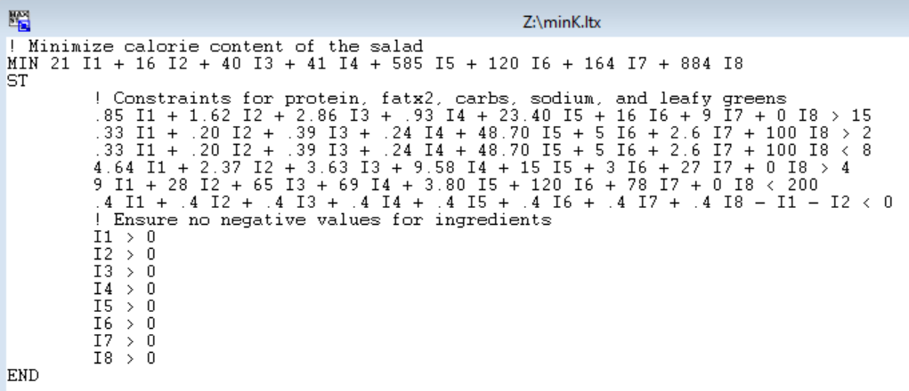

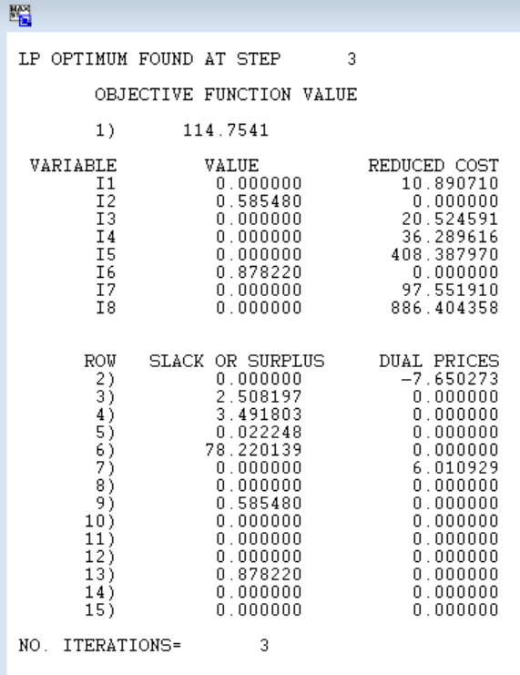

*iii) What is the cost of the low calorie salad?*

The solution is 58.55 grams of Lettuce @ $0.75/100g and 87.82 grams of Smoked Tofu @ $2.15/100g. This results in calories of 114.75 kcal for a **total cost of $2.33.**

*Part B: Determine the combination of ingredients that minimizes calories but meets all nutritional requirements:*

*i) Formulate the problem as a linear program with an objective function and all constraints.*

**Decision Variables**: Iy = 100 grams of each ingredient “y” to include in the salad. Each ingredient is labeled in order with the letter I and an incrementing number.

**Objective Function:** Min D = I1*1.00 + I2*.75 + I3*.50 + I4*.50 + I5*.45 + I6*2.15 + I7*.95 + I8*2.00

Where D = dollars spent

**Resource Constraints:**

**Protein:** I1*.85 + I2*1.62 + I3*2.86 + I4*.93 + I5*23.40 + I6*16 + I7*9 + I8*0 ≥ 15 g of protein

**Fat Min:** I1*.33 + I2*.20 + I3*.39 + I4*.24 + I5*48.70 + I6*5 + I7*2.6 + I8*100 ≥ 2 g of fat

**Fat Max:** I1*.33 + I2*.20 + I3*.39 + I4*.24 + I5*48.70 + I6*5 + I7*2.6 + I8*100 ≤ 8 g of fat

**Carbs:** I1*4.64 + I2*2.37 + I3*3.63 + I4*9.58 + I5*15 + I6*3 + I7*27 + I8*0 ≥ 4 g of carbs

**Sodium:** I1*9 + I2*28 + I3*65 + I4*69 + I5*3.80 + I6*120 + I7*78 + I8*0 ≤ 200 mg of sodium

**Leafy Green:** (I1 + I2 + I3 + I4 + I5 + I6 + I7 + I8)*.4 ≤ I2 + I3

**Non-Negative:** Iy ≥ 0

*ii) Screenshots of determining the optimal solution*

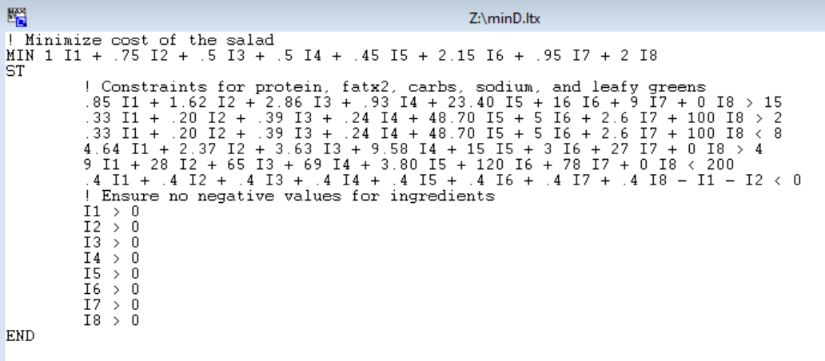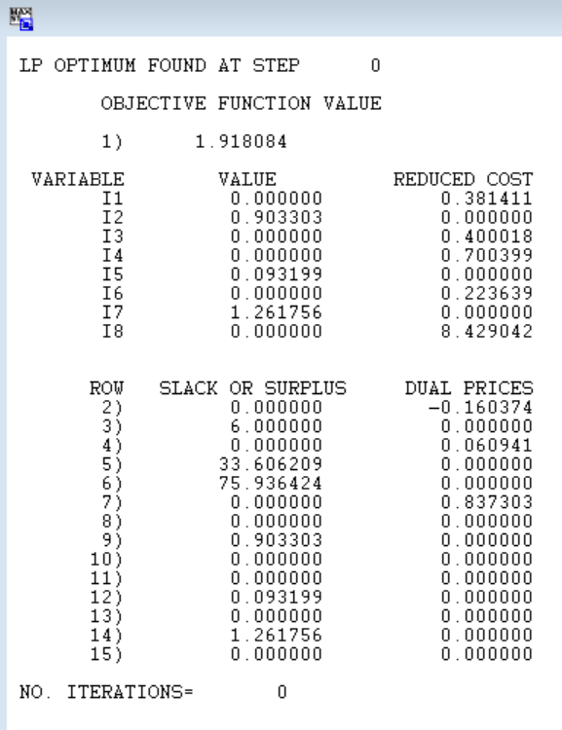

*iii) How many calories are in the low cost salad?*

The solution is 90.33 grams of Lettuce @ 16 kcal/100g, 9.32 grams of Sunflower Seeds @ 585 kcal/100g, and 126.18 grams of Chickpeas @ 164 kcal/100g. This results in a total cost of $1.92 and **275.91 kcal for the salad.**

*Part C: Compare the results from part A and B. Veronica’s goal is to create a Very Veggie Salad that is both low calorie and low cost. She would like to sell the salad for $5.00 and still have a profit of at least $3.00. However if she can advertise that the salad has under 250 calories then she may be able to sell more.*

|  |  |  |
| --- | --- | --- |
|  | Low Calorie | Low Cost |
| Kcal | 114.75 | 275.91 |
| Total Cost | $2.33 | $1.92 |

*i) Suggest some possible ways that she select a combination of ingredients that is “near optimal” for both objectives. This is a type of multi-objective optimization.*

To create a Linear Programming problem that can help the user solve for both of these items, the objective from on problem should become a constraint in the other problem. Typically there might be something specific that is driving the user to decide which one should be the constraints. In this case, the 2 goals are a salad that costs < $2.00, and a salad that has under 250 kcal. In this case, the Low Calorie option is well below the < 250 calorie goal and exceeds the $2.00 cost benchmark. Meanwhile, the Low Cost option is close to the kcal goal at 275.91 and costs $1.92, just barely under the cost goal. Since the low cost solution is near optimal, I would recommend the user adds the low calorie constraint to the low cost problem. The user can then manually modify the low calorie constraint to fine tune the desired results. The user can continue to tighten (improve) the low calorie constraint until the increase in total cost is undesirable (the user will have to be able to decide which is more important after a certain point).

*ii) What combination of ingredient would you suggest and what is the associated cost and calorie.*

The problem setup:

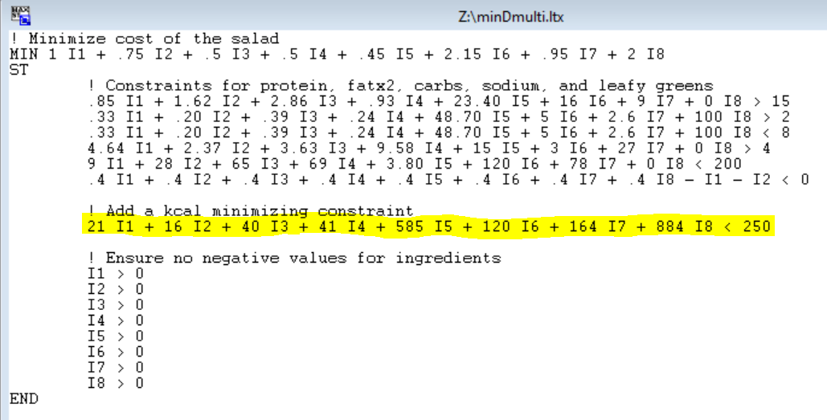

Examples of Solutions:

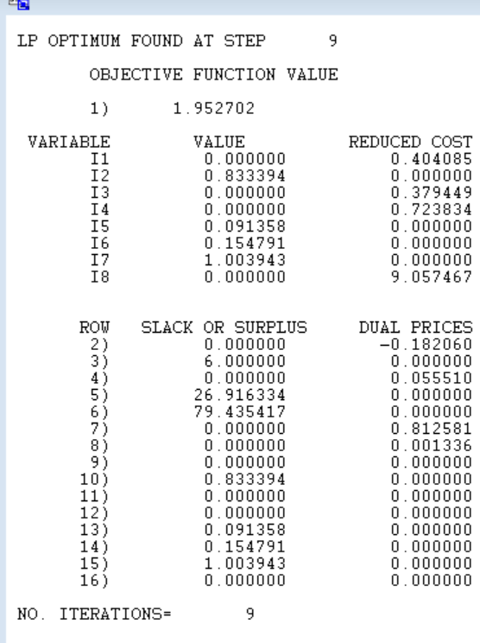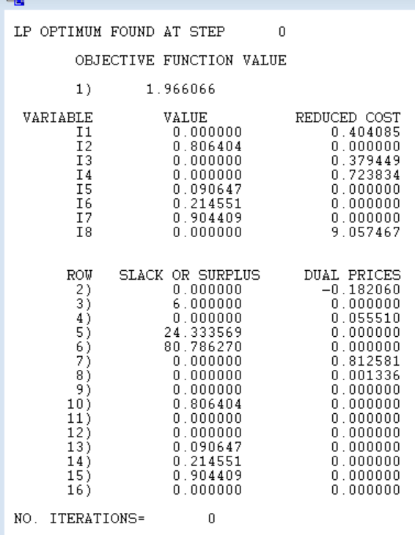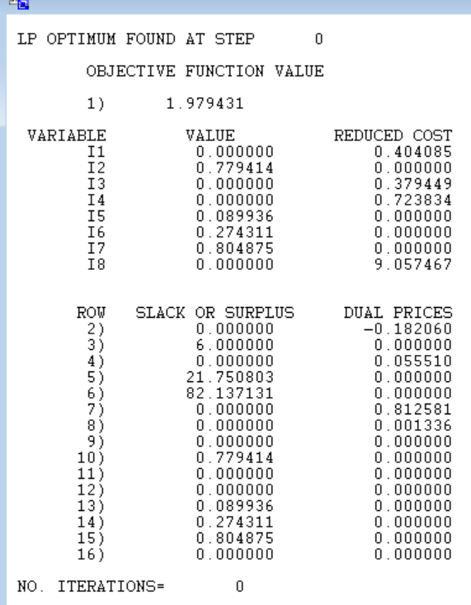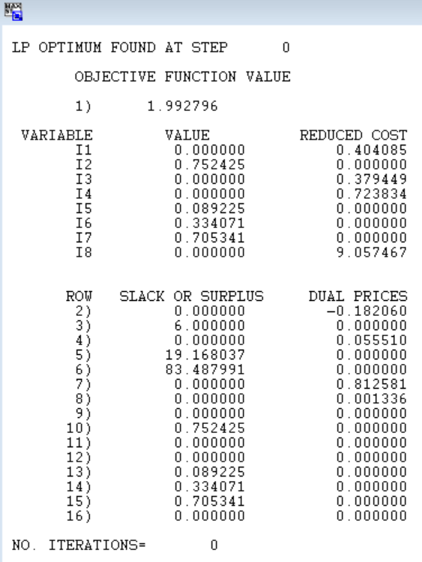

Results Table:

|  |  |  |
| --- | --- | --- |
| Calorie Constraint | Total kcal | Total Cost |
| <250 | 250.00 | $1.95 |
| <240 | 240.00 | $1.97 |
| <230 | 230.00 | $1.98 |
| <220 | 220.00 | $1.99 |

From a business perspective, assuming no incremental gain from lowering calories below 249 (one below 250 so the business is not caught lying and slandered in the media), the optimal solution would be 249 kcal at a cost of $1.95. This is achieved by using 83.07 grams of Lettuce, 9.13 grams of Sunflower Seeds, 16.08 grams of Smoked Tofu, and 99.40 grams of Chickpeas.

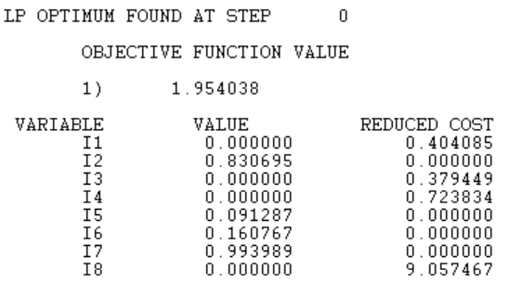

*iii) Note: There is not one “right” answer. Discuss how you derived your solution.*

As noted above, the solution was derived through a series of guess and check activities, starting with the minimum accepted answer (kcal below 250 to increase sales). From there, it was apparent that lowering kcal would result in increased costs. Since there is no incremental gain listed between 250 kcal and 220 kcal for this problem, than it is not worth incurring the extra cost. In a real world scenario, it might be worth using the lower kcal values at higher cost because the added marketing leverage could potentially increase sales.